Adding New Columns to Scorecard Tables

Below are the most common steps that need to happen while new columns to ORDER_ITEM_SHIPMENT, ORDER_ITEM_OPEN Tables.

SCD Schema

Tables
- ORDER_ITEM_SHIPMENT
- ORDER_ITEM_OPEN
- TEMP_ORDER_ITEM_SHIPMENT
- ORDER_ITEM_SHIPMENT_HISTORY

Sample Scripts
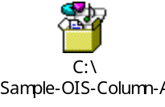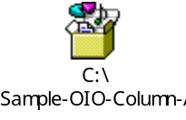

Views
- ORDER_ITEM_OPEN_V
- ORDER_ITEM_SHIPMENT_COST
- ORDER_ITEM_SHIPMENT_NOCOST
- ORDER_ITEM_SHIPMENT_V

SCD_SOURCE Schema

Packages:

As needed below Packages need to be modified:

- PKG_DELVSCD_DATA_LOAD
- PKG_EXTRACT_ADR43
- PKG_HISTORY
- PKG_ORDER_ITEM_PROCESS

